Ideation Phase
Define the Problem Statements

Date | 18 February 2026
Team ID | LTVIP2026TMIDS24254
Project Name | Visualization Tool For Electric Vehicle Charge And Range Analysis
Maximum Marks | 2 Marks
Customer Problem Statement Template:
Create a problem statement to understand your customer's point of view. The Customer Problem Statement template helps you focus on what matters to create experiences people will love.
A well-articulated customer problem statement allows you and your team to find the ideal solution for the challenges your customers face. Throughout the process, you’ll also be able to empathize with your customers, which helps you better understand how they perceive your product or service.
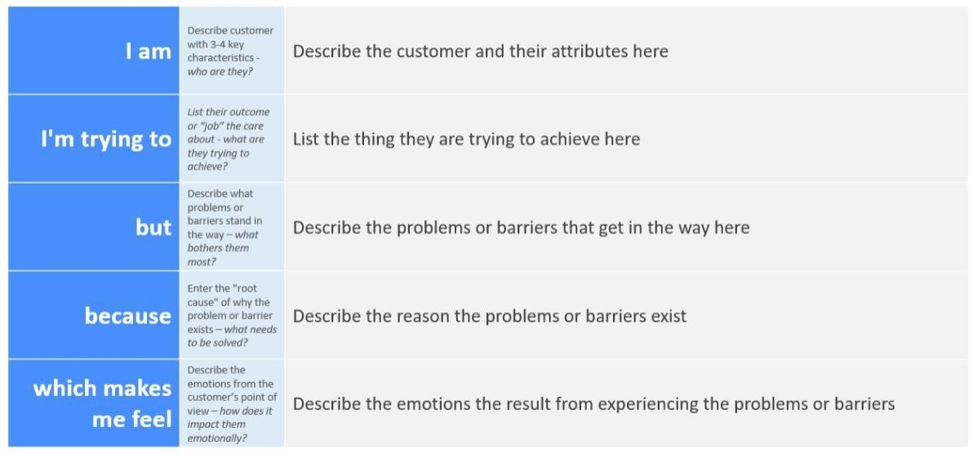
Reference: https://miro.com/templates/customer-problem-statement/
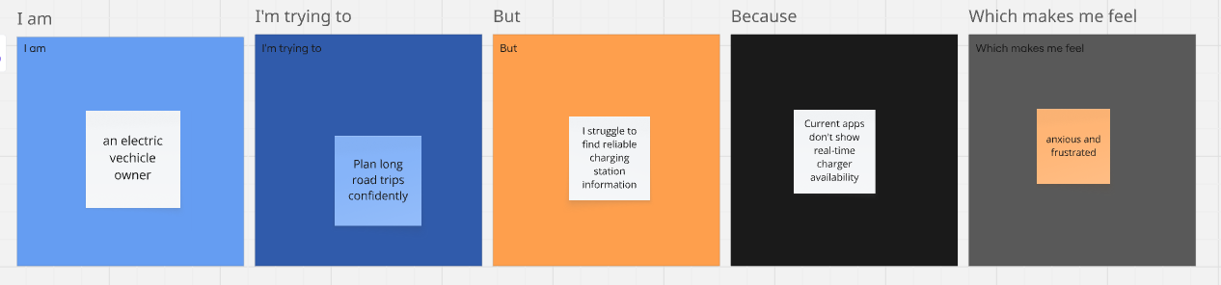
Example:

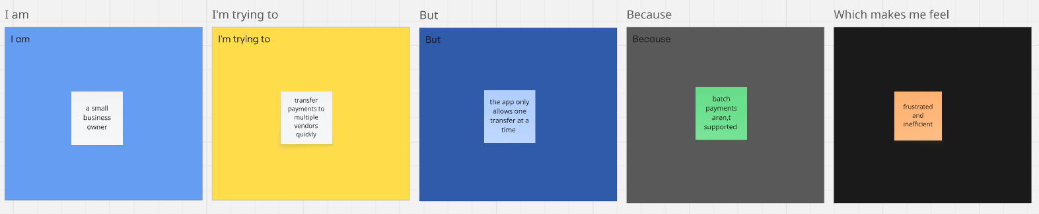

Problem Statement (PS) | I am (Customer) | I’m trying to | But | Because | Which makes me feel
PS-1 | An electric vehicle owner | Plan long road trips confidently | I struggle to find reliable charging station information | Current apps don’t show real time charger availability | Anxious and frustrated
PS-2 | A small business owner | Transfer payments to multiple vendors quickly | The app only allows one transfer at a time | Batch payments are not supported | Frustrated and inefficient

2.2 EMpathy map

